DIS-Asia-Gandhara-Buddha-Seated-Limestone-ca.100-300 AD-CE

Repaired/Restored, height 16 cm., width 10 cm. Ex Japanese Collection

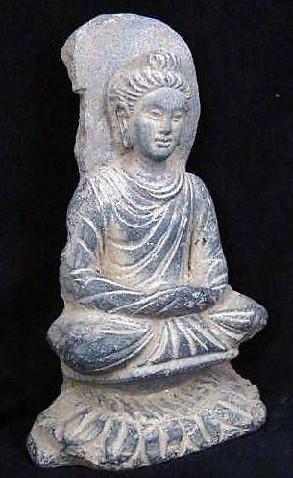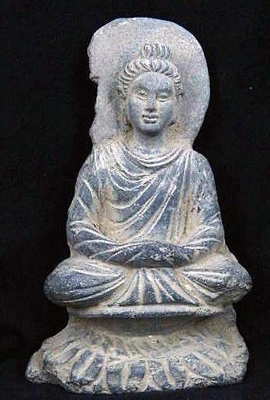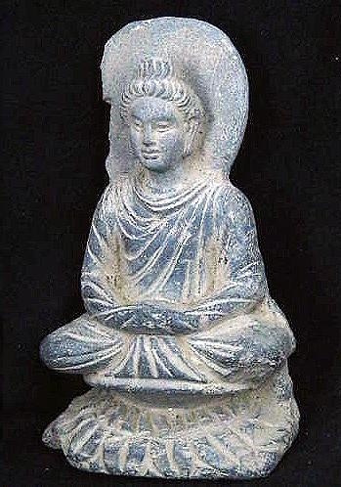

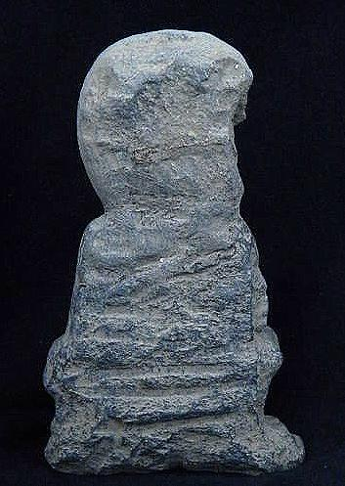

# Order details

## Sales order

Sold by [sak2014*14](http://myworld.ebay.com/sak2014*14) ( [341](http://feedback.ebay.com/ws/eBayISAPI.dll?ViewFeedback&userid=sak2014*14) )

### Delivery package 1 of 1

Estimated delivery Tuesday, Feb 2, 2016 - Monday, Feb 22, 2016

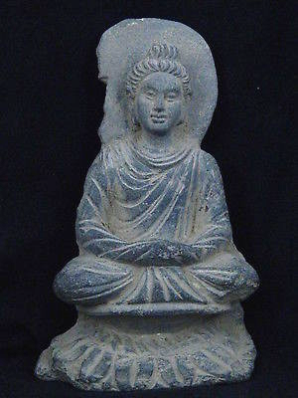

#### [Ancient Large Stone Seated Buddha Gandharan/Gandhara 100 AD #S2758](http://www.ebay.com/itm/111772787824)

|  |  |
| --- | --- |
| Item price | $500.00 |
| Quantity | 1 |
| Item number | 111772787824 |
| Shipping service | Economy Shipping from outside US |